Nmap and Zenmap Lab

Ryan Coon

CYB-505

Professor Devin Ogg

July 31, 2021

**Part 1:**

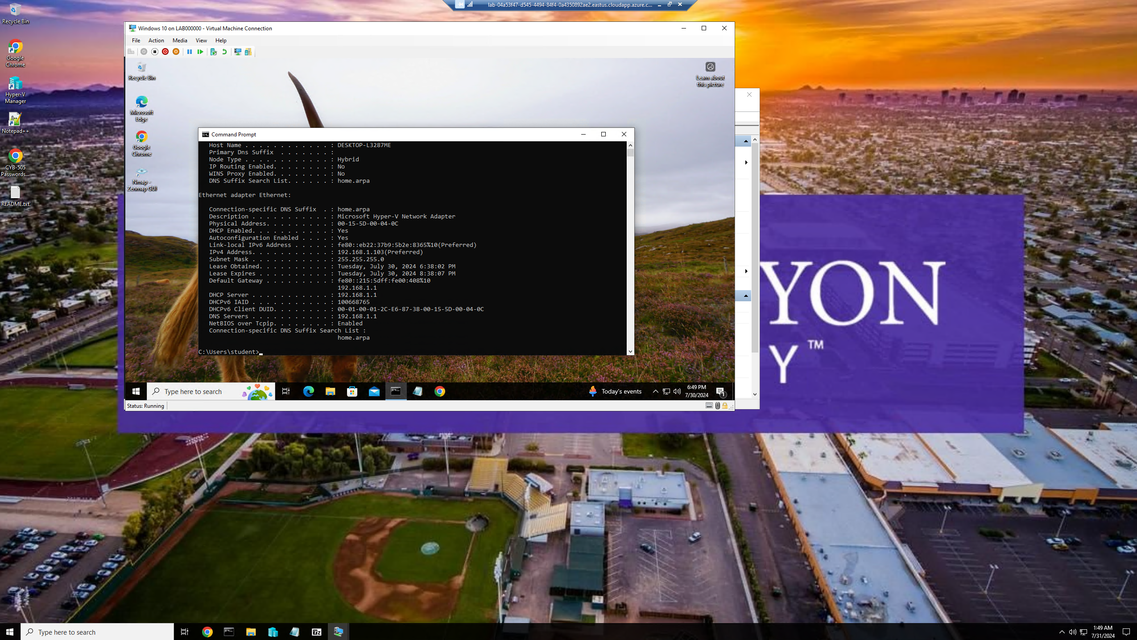

Windows 10 IP address

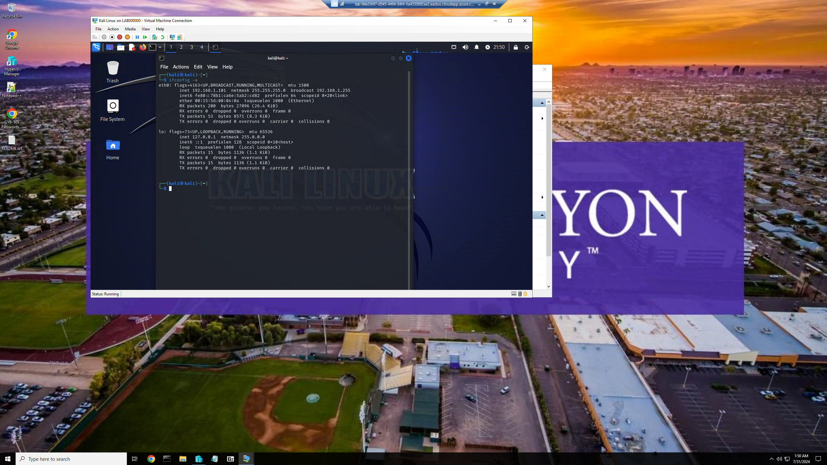

Kali Linux IP address

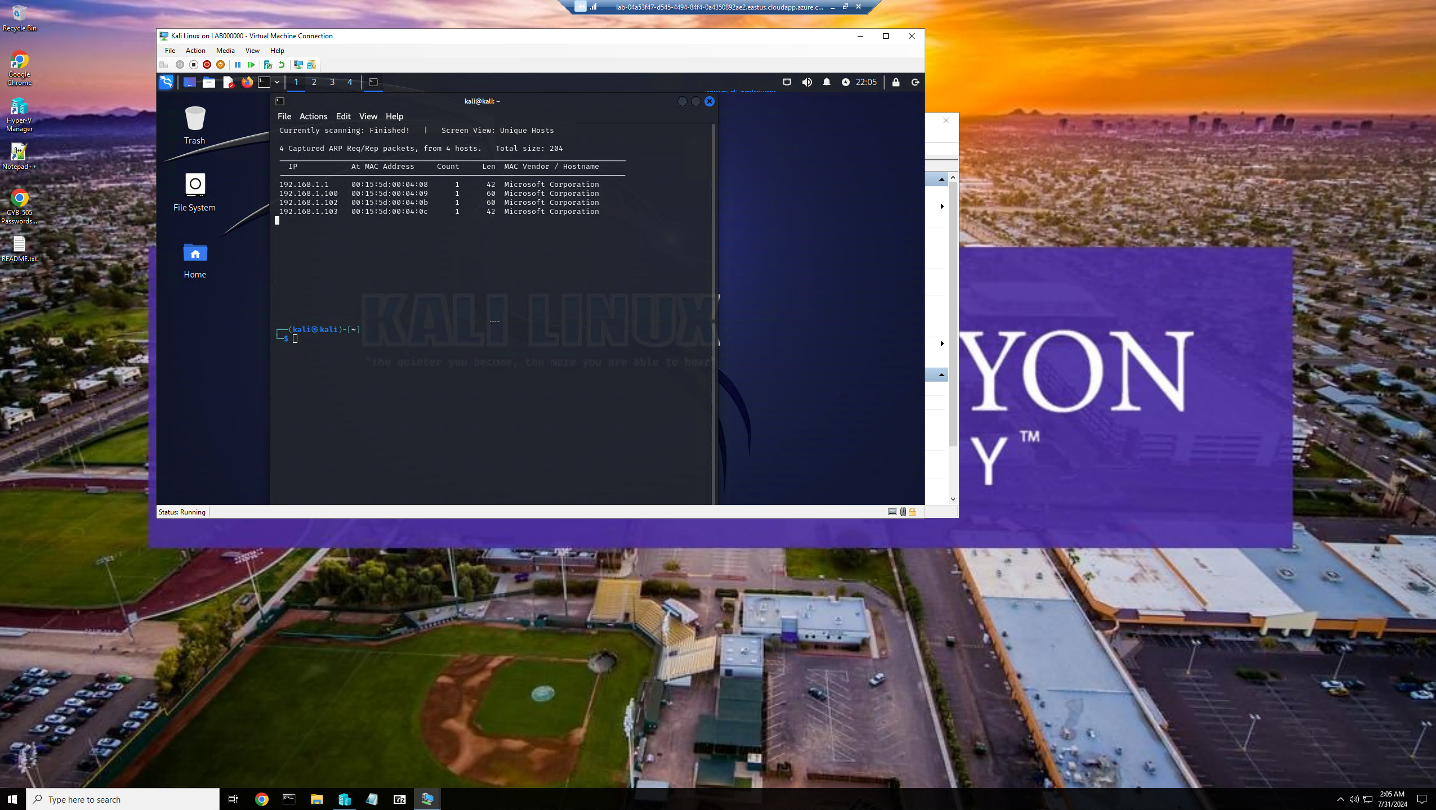

Netdiscover ran on Kali Linux

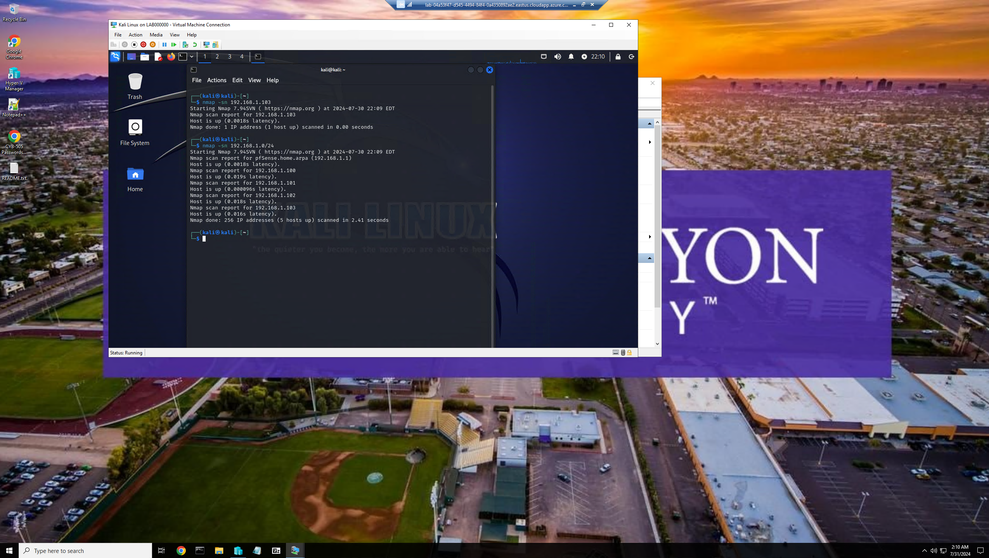

Nmap -sn ping scan ran on Kali server pinging Windows 10 server then the whole subnet

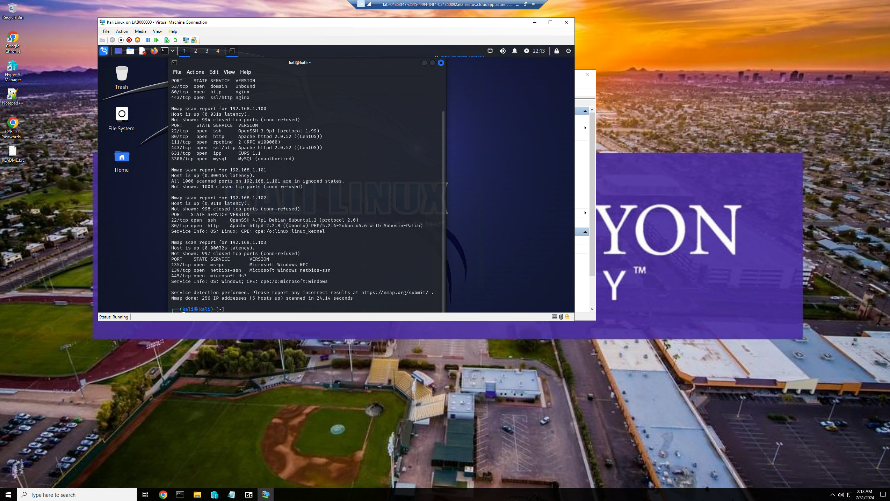

Nmap -sV scan ran to scan the whole subnet

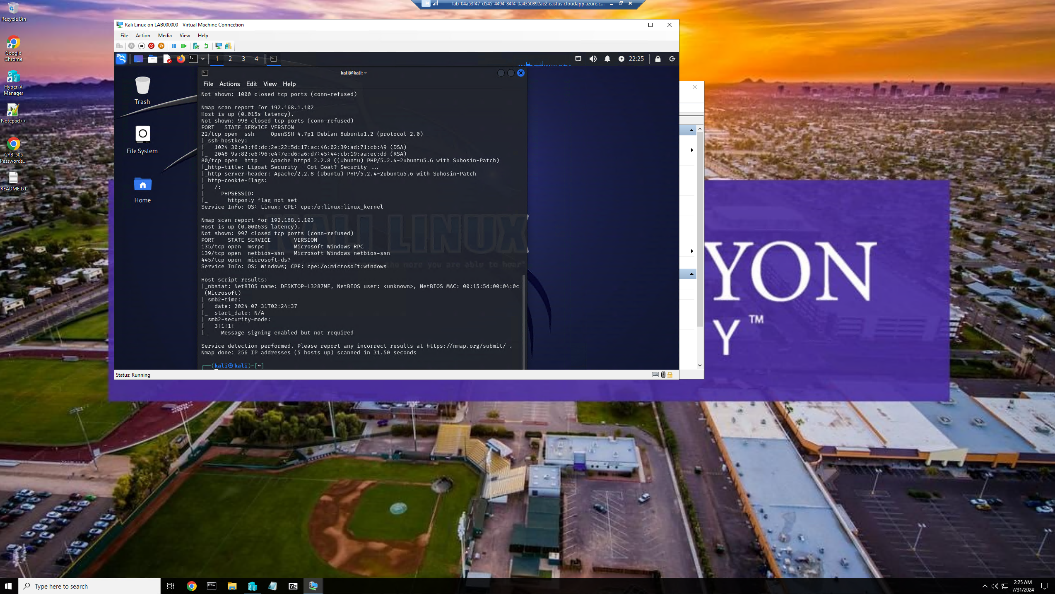

Nmap -A or intrusive scan ran to the whole subnet

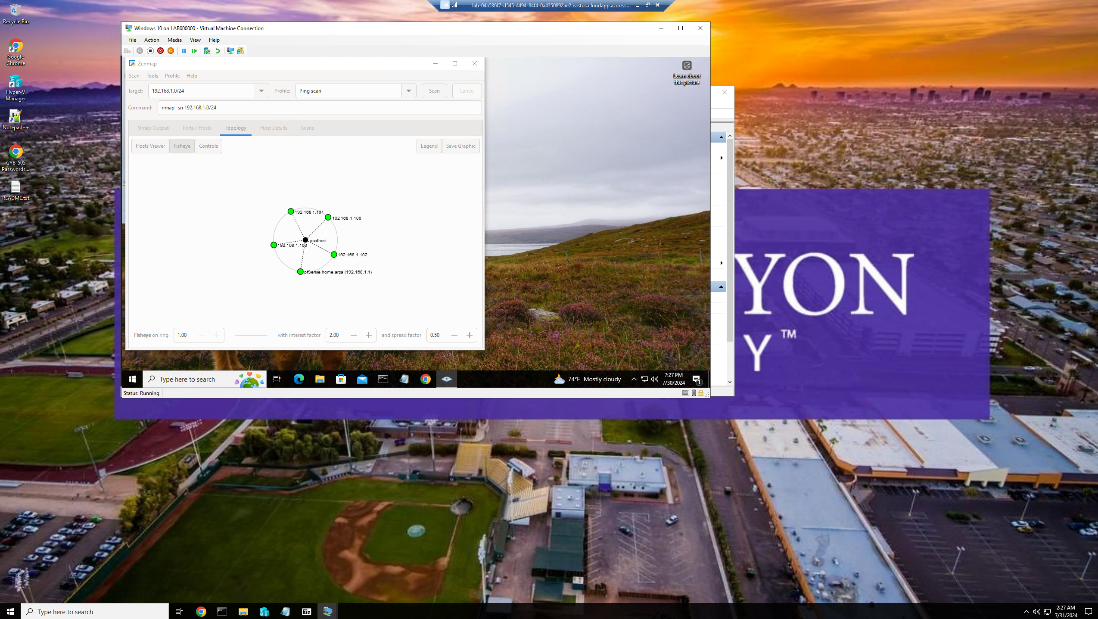

Whole subnet on Zenmap network topology

**Part 2:**

**Identify what operating system is running on your Windows 10 system.**

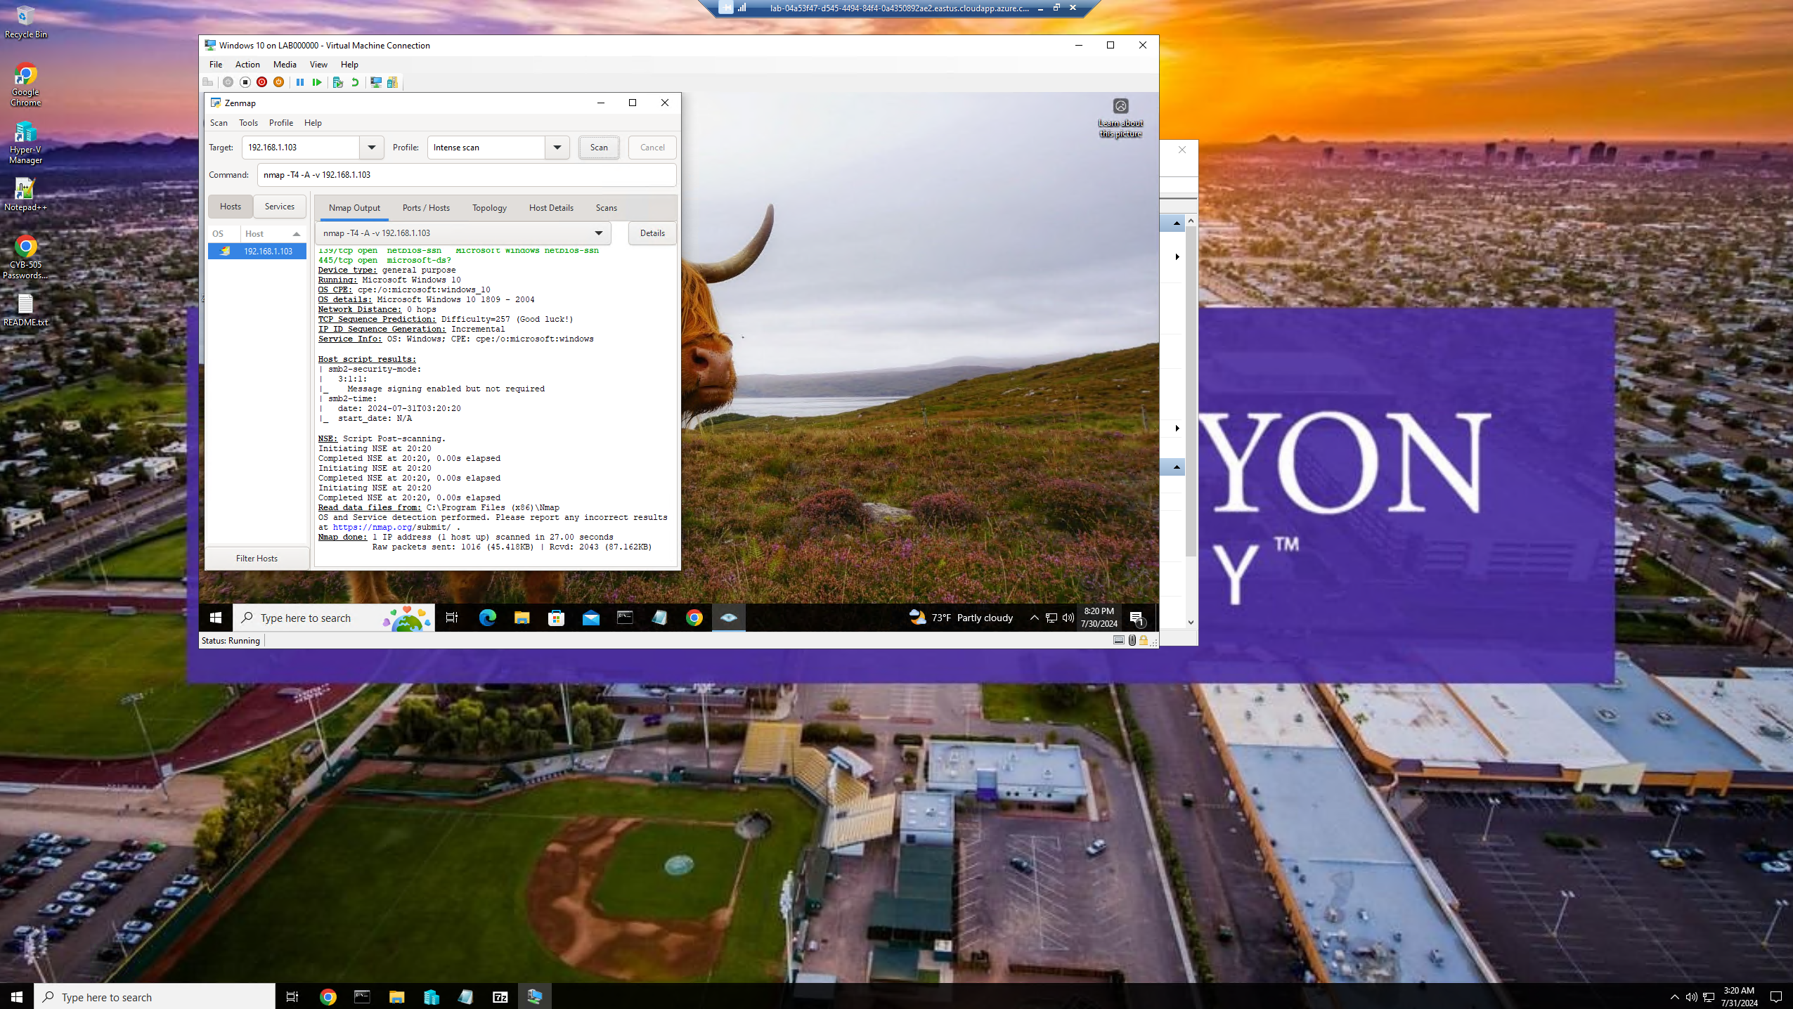

After running an intense scan on ip address 192.168.1.103, we can see that the operating system on this server is a Windows 10 version 1809 from 2004.

**Describe what is meant by an intrusive scan.**

An intrusive scan refers to a type of security assessment or penetration testing technique that actively probes and examines a target system or network in a comprehensive and aggressive manner to identify vulnerabilities, weaknesses, or potential security risks.

Characteristics of an Intrusive Scan:

Aggressive Nature - Intrusive scans are characterized by their aggressive and thorough approach to identifying security vulnerabilities by actively probing the target system.

Comprehensive Testing - These scans often involve in-depth testing methodologies and tools to uncover potential weaknesses in the target system's security defenses.

Active Probing - Intrusive scans actively send network packets or perform actions that could potentially disrupt or exploit vulnerabilities in the target system to assess its security posture.

Intensive Analysis - They may include detailed vulnerability assessments, exploitation attempts, and active reconnaissance to identify security gaps.

Potential Impact - Due to their aggressive nature, intrusive scans have the potential to disrupt or impact the normal operation of the target system, making them more intrusive compared to passive scanning techniques.

Purpose of an Intrusive Scan:

Identifying Vulnerabilities - The primary goal of an intrusive scan is to identify vulnerabilities, misconfigurations, or weaknesses in the target system that could be exploited by malicious actors.

Security Assessment - Intrusive scans help organizations assess the effectiveness of their security measures and identify areas that require improvement to enhance the overall security posture.

Penetration Testing - They are often used as part of penetration testing exercises to simulate real-world attack scenarios and test the resilience of the target system against potential threats.

Risk Mitigation - By uncovering vulnerabilities through intrusive scans, organizations can proactively address security risks and implement appropriate remediation measures to strengthen their defenses.

**Summarize what your two additional NMAP scans do and provide screenshots.**

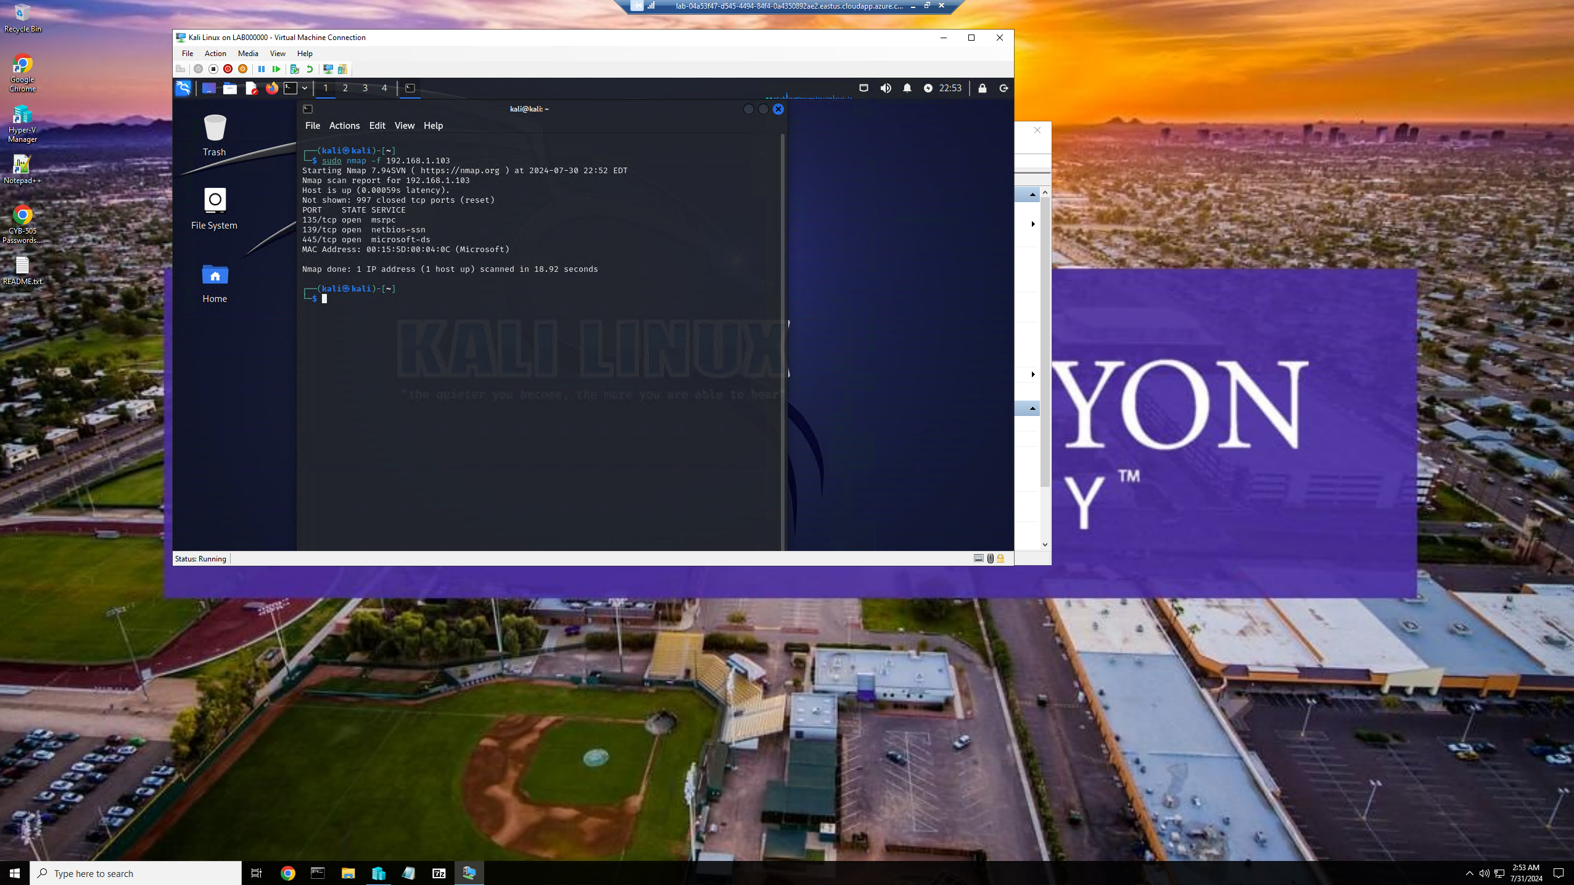

Here I ran sudo nmap -f 192.168.1.103. The -f flag allows for packet fragmentation during scanning, which can aid in stealth scanning, firewall evasion, and OS fingerprinting techniques.

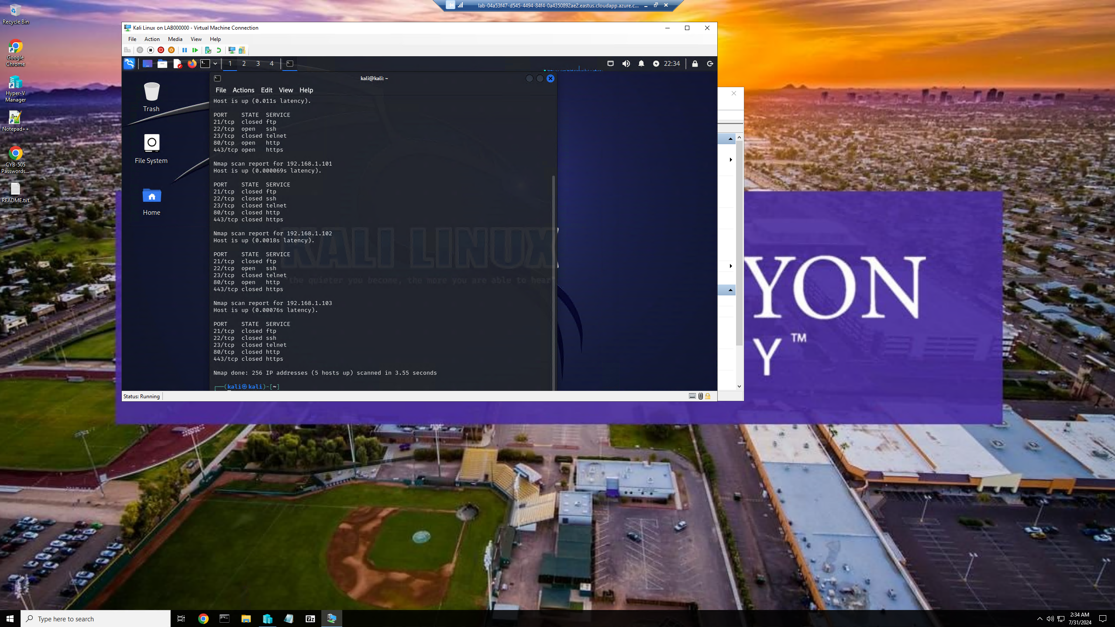

Here I ran nmap –top-ports 5 192.168.1.0/24. This nmap scan enables you to scan a predefined list of commonly used ports efficiently and effectively during network reconnaissance.

References:

House, N. (2017, July 19). *Nmap Cheat Sheet*. Station X. https://www.stationx.net/nmap-cheat-sheet/

*Intrusive vs. Nonintrusive Scanning*. (n.d.). Www.itprotoday.com. Retrieved July 31, 2024, from https://www.itprotoday.com/it-security/intrusive-vs-nonintrusive-scanning

*The Importance Of Intrusion Detection Systems In Cybersecurity*. (n.d.). Cyber Security Consulting Ops. https://www.cybersecurityconsultingops.com/the-importance-of-intrusion-detection-systems-in-cybersecurity/

*What is Vulnerability Scanning?* (n.d.). Www.beyondtrust.com. https://www.beyondtrust.com/resources/glossary/vulnerability-scanning